**Practical No. 2**

1. **Using Packet Tracer, create a basic network of two**

**computers using appropriate network wire.**

**Use Static IP address allocation and show connectivity.**

**Step 1: Click on ‘End Devices’ and select ‘PC’**

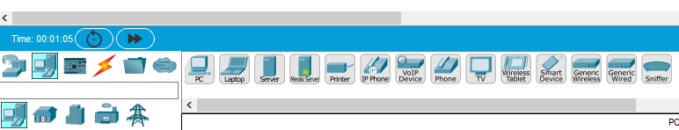

**Step 2: Drag and drop a ‘PC’ anywhere on screen**

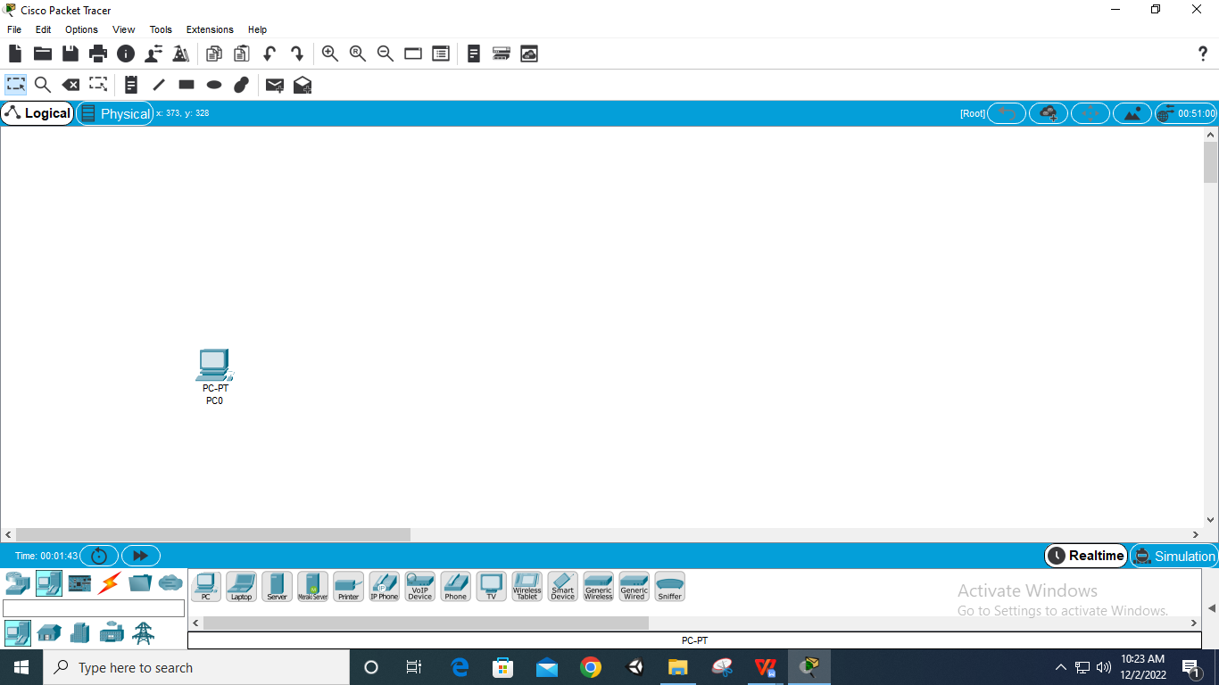

**Step 3: Drag and drop another ‘PC’ anywhere on screen**

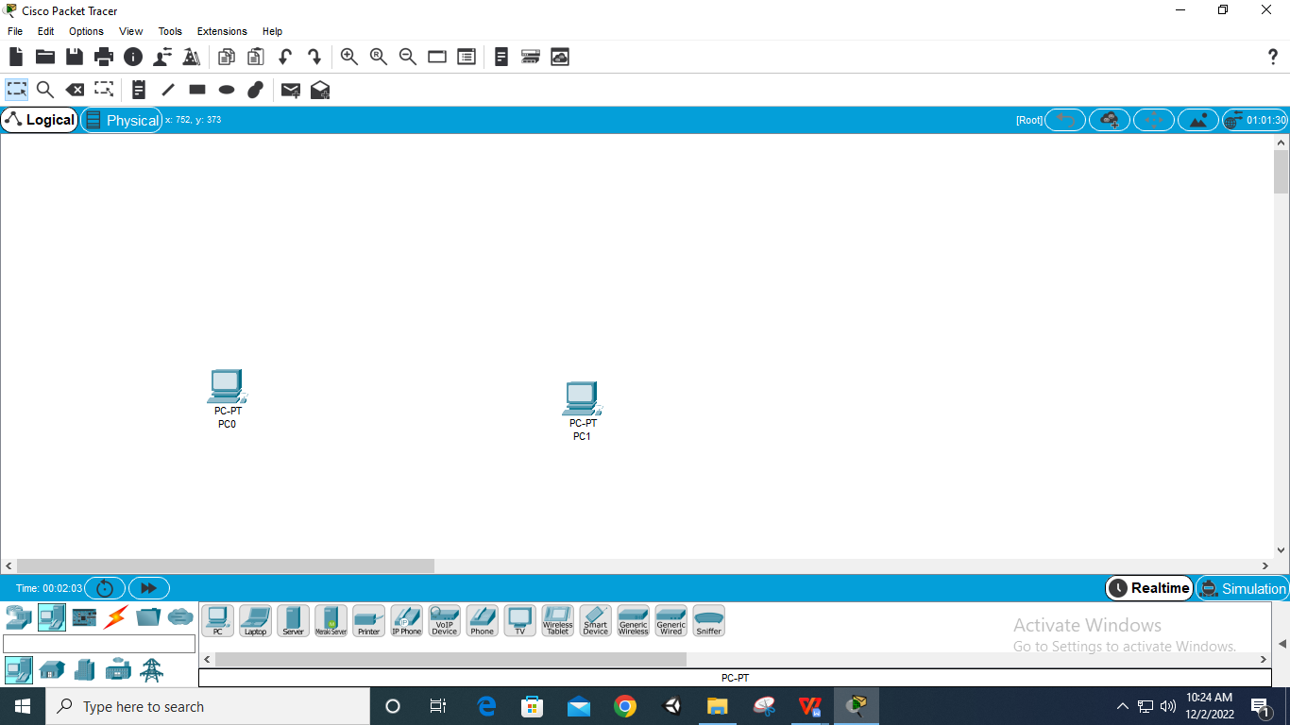

**Step 4: Click on ‘PC0’ and select ‘IP Configuration’**

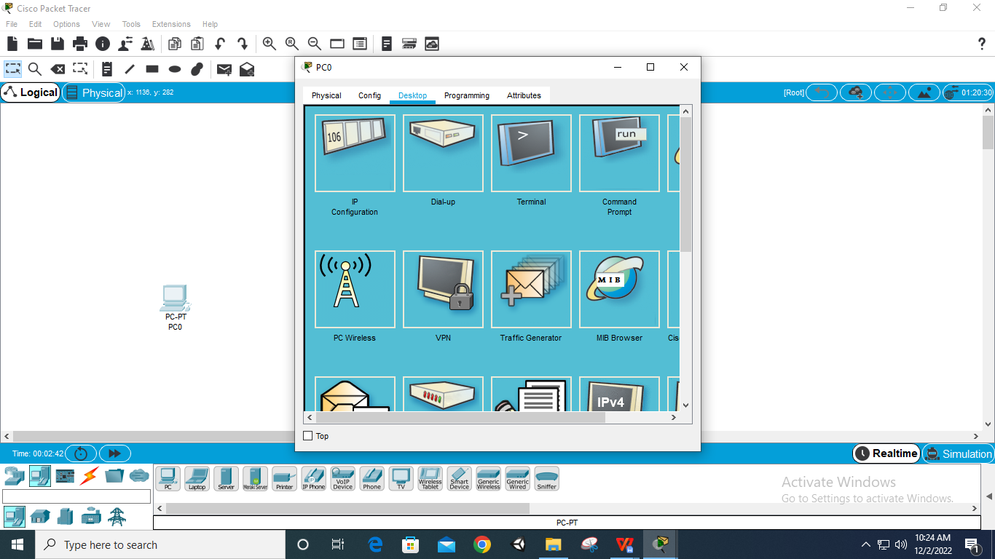

**Step 5: Add ‘IPv4 Address’ and ‘Subnet Mask’ to ‘PC0’**

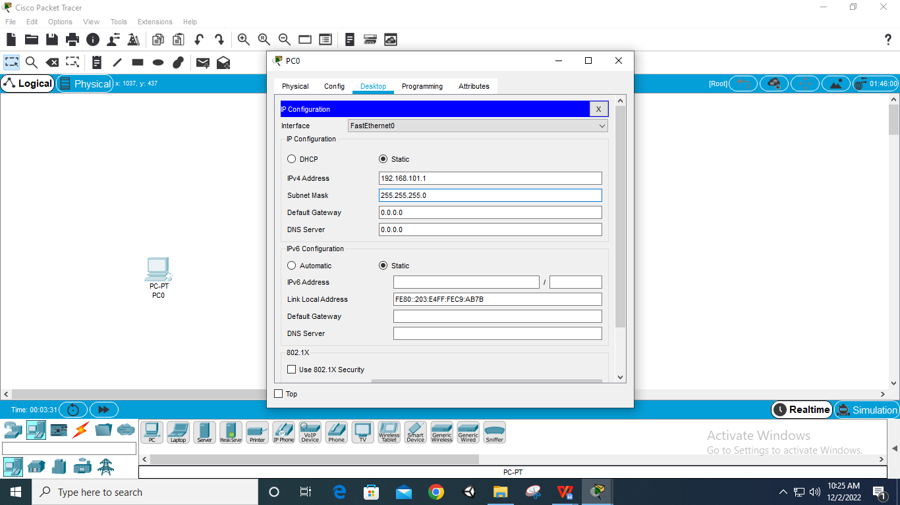

**Step 6: Click on ‘PC1’ and select ‘IP Configuration’**

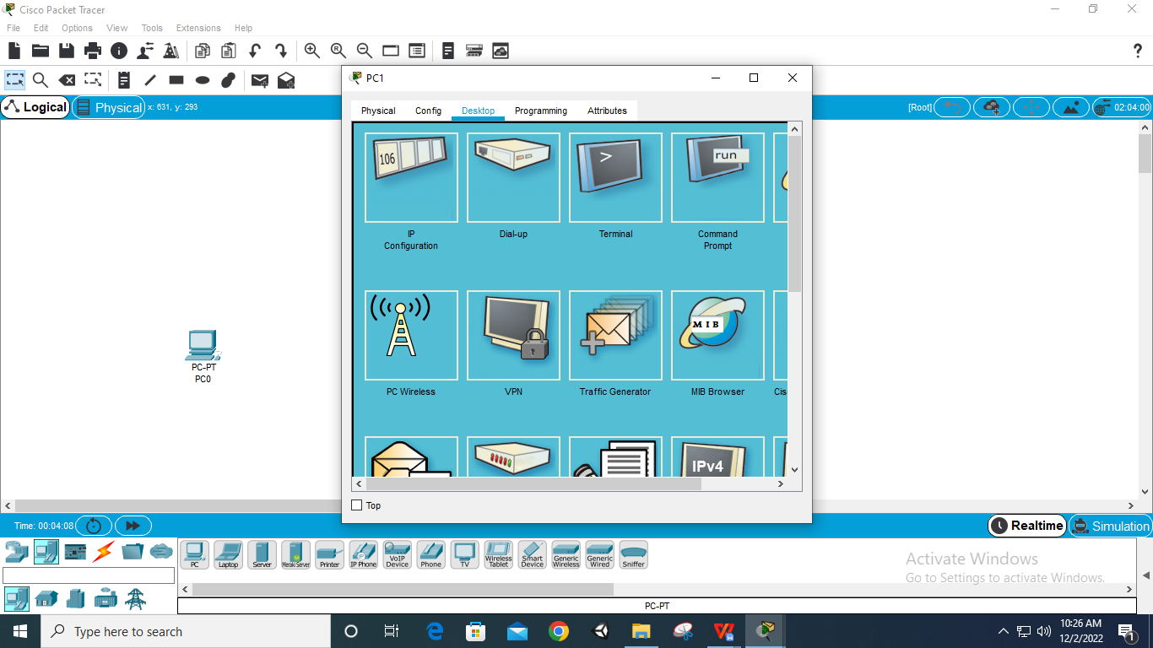

**Step 7: Add ‘IPv4 Address’ and ‘Subnet Mask’ to ‘PC1’**

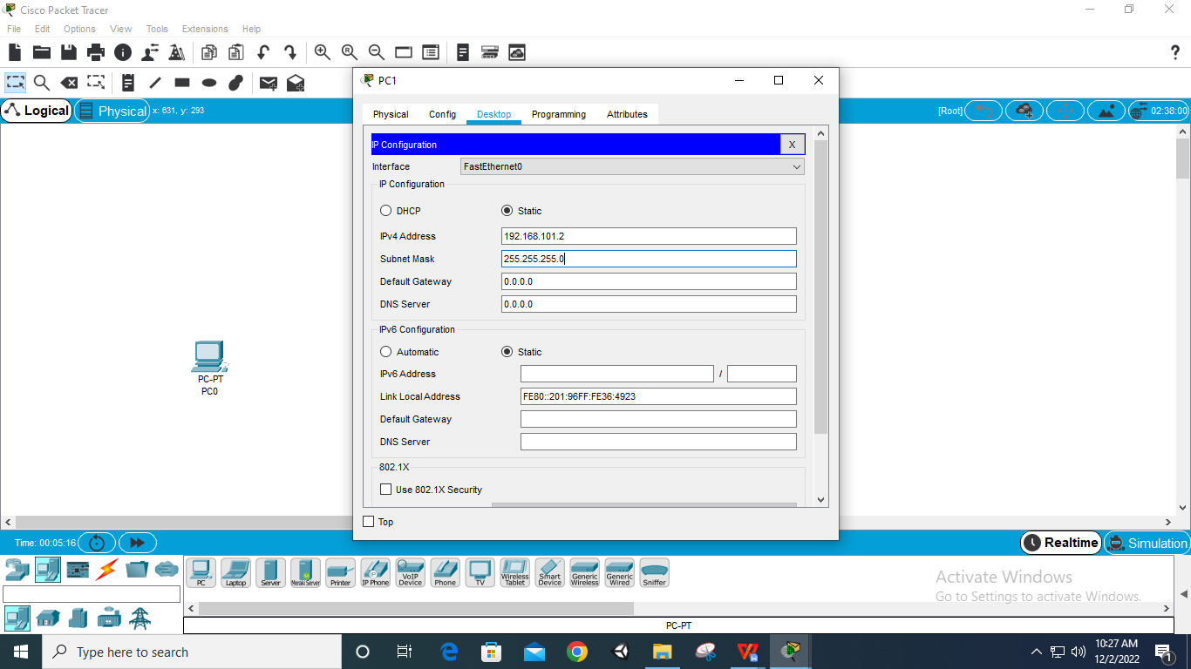

**Step 8: Select Connection Wire**

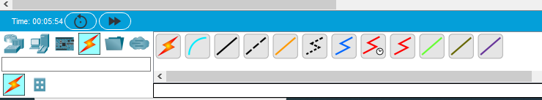

**Step 9: Add Connection Wire between ‘PC0’ and ‘PC1’**

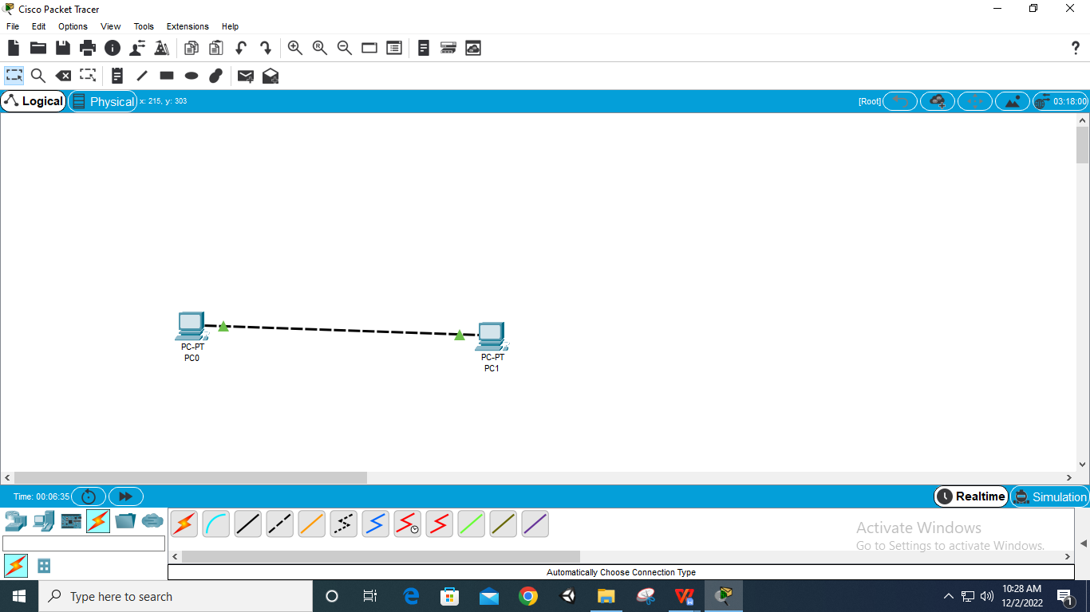

**Step 10: Select ‘Add Simple PDU’(Packege)**

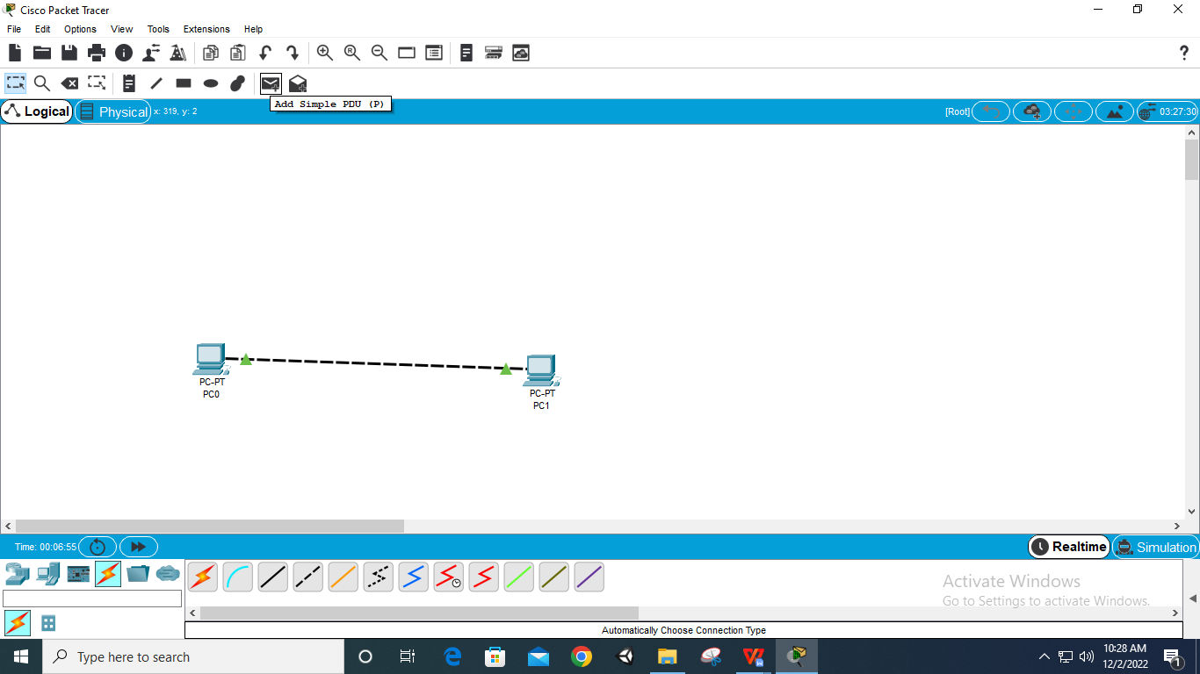

**Step 11: Select package and assign it to ‘PC0’ and ‘PC1’**

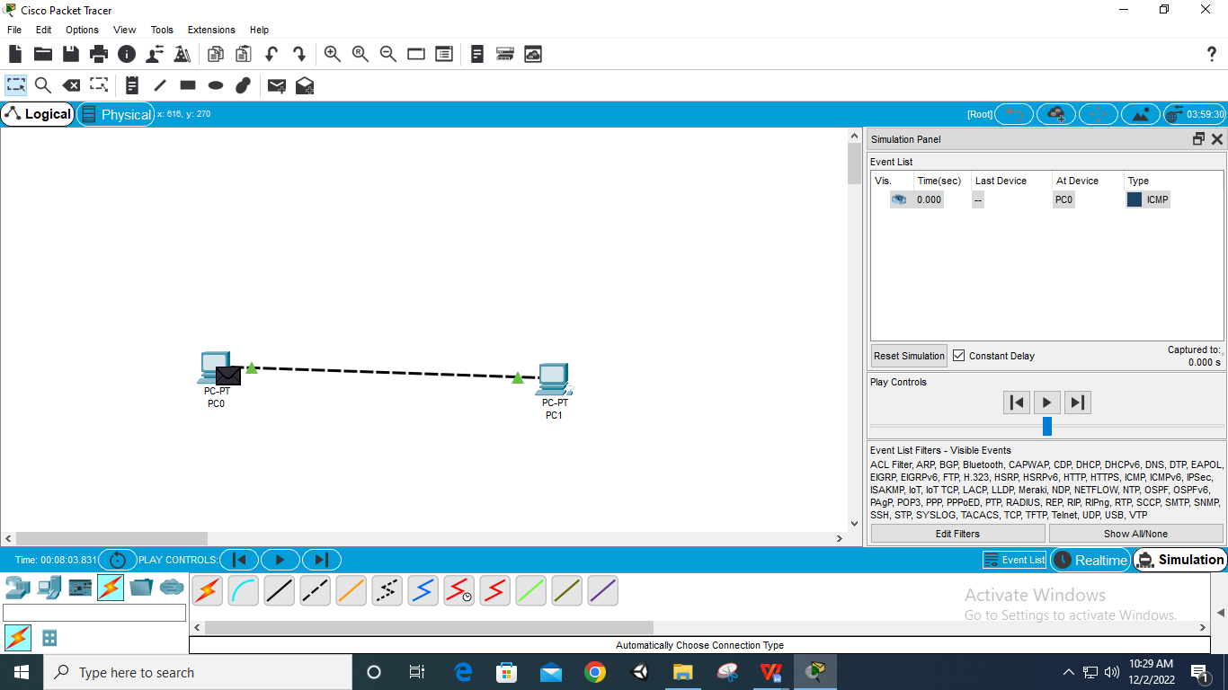

**Step 12: Click on ‘Simulation’ and ‘play’ it.**

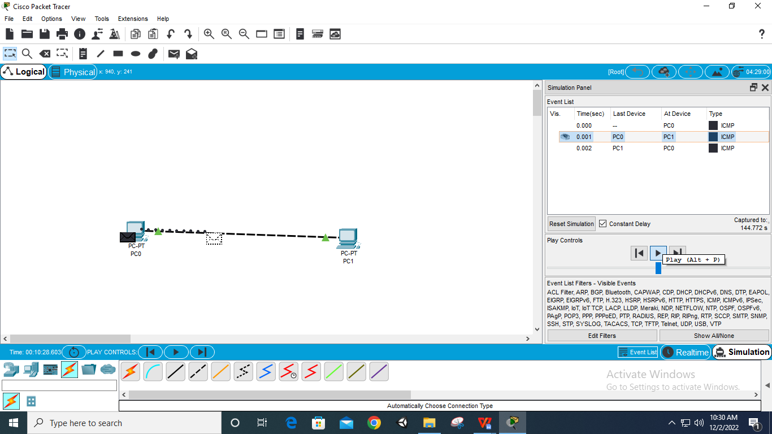

**Package passing from ‘PC0’ to ‘PC1’**



**Package passing from ‘PC1’ to ‘PC0’**

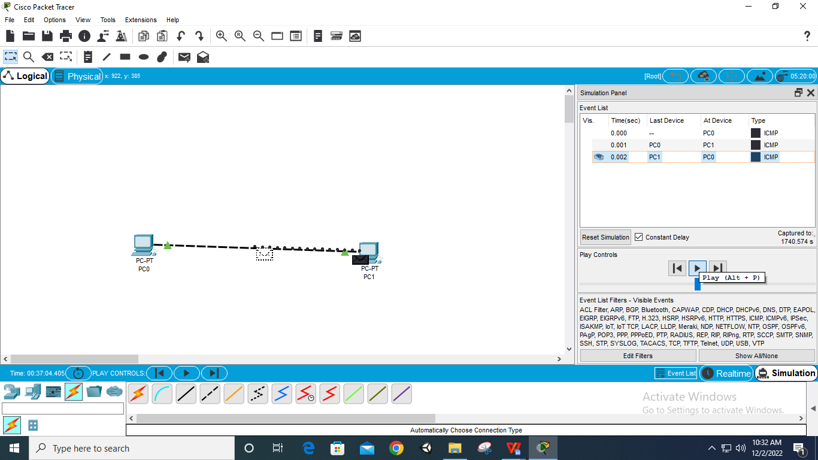

**Connection Completed**

